Introduction to Python

- Python was designed by Guido Van Rossum
- Readable -Python is a readable language because it is very similar to English
- short duration to code- The time taken to code in python is very less when compared to the other programming languages
- large libraries – The python has may built-in modules.
- large Ecosystem
- Cross Platforms-Python is platform independent as it can run on windows, mac etc
- Massive Community- Millions of people use python so we can find solutions easily
- Excellent Integration
- Applications of Python – Python is widely used for web development, data science ,artificial intelligence, machine learning etc
- It has gained widespread use in machine learning
- The Pythons large standard library is commonly cited as one of the greatest strengths.
- Python vs java: Python is known for its simple and readable syntax, making it beginner-friendly. It requires fewer lines of code and avoids boilerplate, allowing developers to focus on logic rather than syntax. Java, on the other hand, is more verbose and requires explicit declarations, which can make it harder for beginners but ensures clarity in large-scale projects.
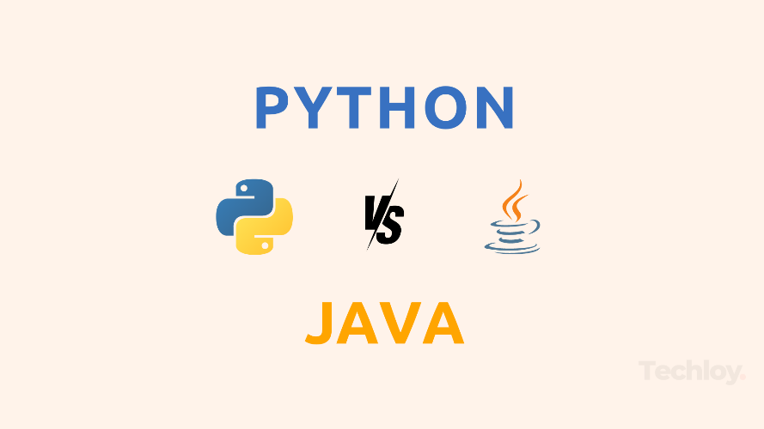

- Performance: Java is faster than Python due to its compiled nature. Java code is converted into bytecode and executed by the Java Virtual Machine (JVM), and hence the performance is optimized. Python, being an interpreted language, processes code line by line, so that the time taken is more and the process is also slow.
- Frameworks and libraries: Python has fewer but highly efficient frameworks like Django and Flask for web development, and libraries like PyTorch for machine learning. Java offers a broader range of frameworks.
- Python and C++: As we know the syntax of python is simple and readable so that it becomes highly beginner friendly. Whereas the c++ has complex syntax with declarations,braces,semicolons hence it is hard for beginners .
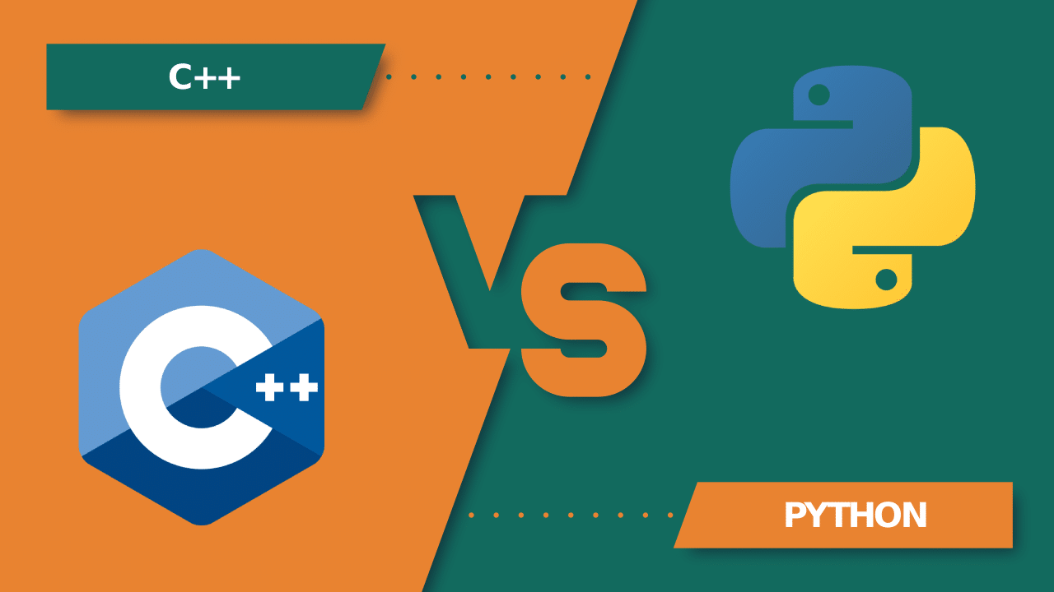
- C++ is used widely for game development and python is used for machine learning and web development.

